Semester I
Unit 1 (short story) | Unit 2 (Novel) | Unit 3 (Novel) | Unit 4 (Odyssey)
R Comp  R Analysis  W Argumentative  C Presentation? | R Comp  W Inform  C Discussion  South add:  W Informative  C Presentation  North add:  R Analysis  W Argumentative | R Comp  R Analysis  W Inform  C Discussion | R Comp  W Argumentative  C Presentation  C MLA
Semester I  Comp- 3  Analysis-2  Argumentative-2  Informative-1  Presentation-2  Discussion-2  *MLA-2 (1 writing/1 comm) | Semester II  Comp-2  Analysis-2  Argumentative-2  Informative-1  Presentation-1  Discussion-2  *MLA-2 (1 writing/1 comm)
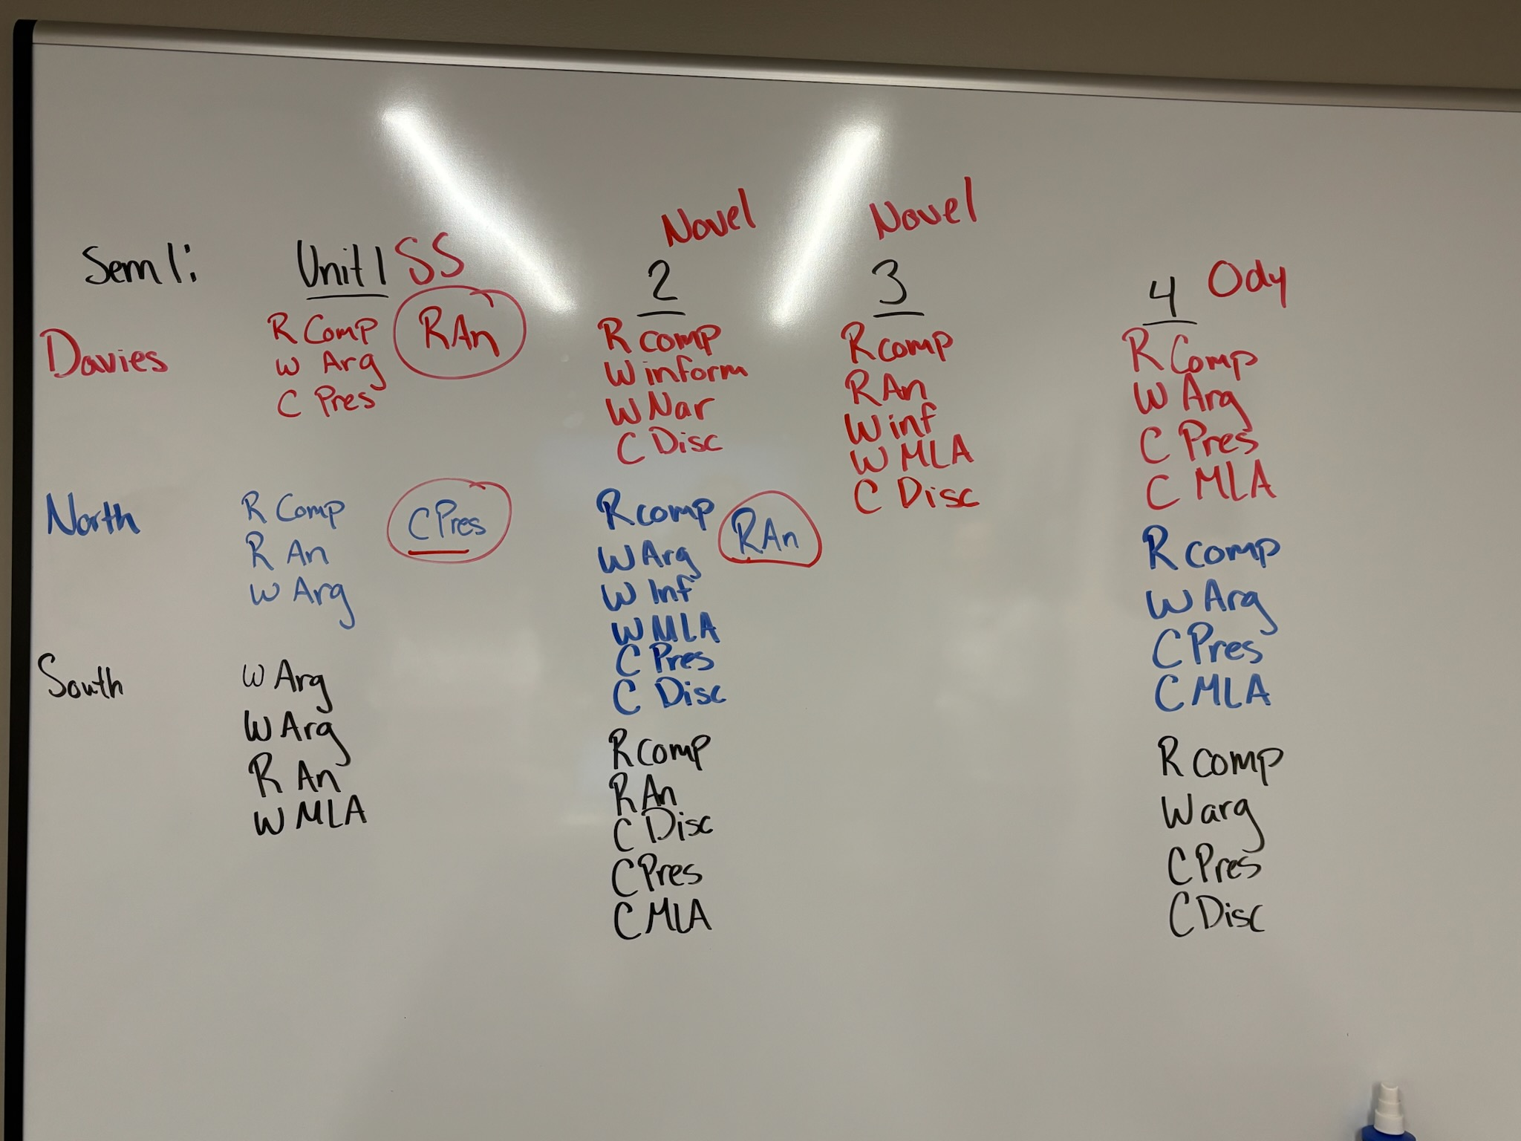
Semester II: Poetry, Romeo and Juliet, Book Study, Research
Unit 1 ( | Unit 2 ( | Unit 3 ( | Unit 4 (
R Comp 2-3 (all hitting 5)
R Analysis 2-3 ((all hitting 5)
W Argumentative 2 (North 1 extra argument)
W Informative 1
C Presentation 1-3
C Discussion 1-3

Writing MLA
Research & Inquiry Recommendation for GAME
- Keep it a separate score
- No more than 1 of these scores per skill per semester
- Building PLC team will decide the skill/game following the rules above

